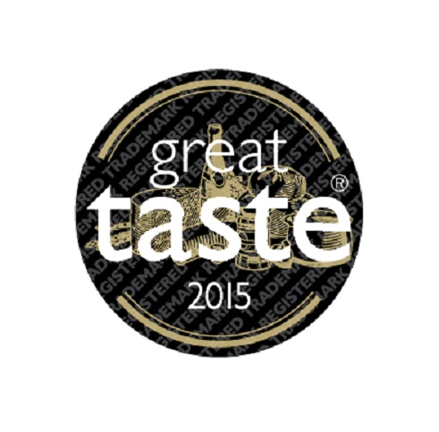
P R E S S R E L E A S E

A rich vein of nostalgia meets a wave of innovative indulgence in the Great Taste 2015 Top 50 Foods

In the last 21 years, Great Taste judges have blind-tasted over 100,000 different products and as this year’s awards reach a nerve-racking finale, judges have now chosen the Great Taste 2015 Top 50 Foods, from which the Supreme Champion will be selected. This year’s Top 50 is a melting pot of humble staples, rich and voluptuous treats and dynamic flavour marriages, all shining through with one thing in common – Great Taste. Shirgar Welsh Salted Butter by Gower View Foods Ltd and Beef Dripping by James Whelan Butchers wave the flag for the pure and simply delicious classics, while inventive flavour combinations were taken to a whole new level by producers such as Beckleberry’s, with its Passionfruit and Tarragon Sorbet.

The Top 50 Foods list, which has been whittled down from 10,000 entries by the most experienced and professional food judges who have blind-tasted each and every product before declaring it truly worthy of its position, is now available for all to see on www.greattasteawards.co.uk and most importantly – to taste. From a “juicy and succulent” Gloucester Old Spot spare rib pork joint and a “clean and fresh” Organic Double Cream to a “distinctive and complex” Sparkling Beer Brut and a “nutty and buttery” Macadamia Nut Oil, the Top 50 Foods is a culinary journey of the most exquisite, delicious and WOW foods in the UK and beyond.

John Farrand, managing director of the Guild of Fine Food, explains; “This year’s Top 50 says so much about the evolution of taste in the UK today. On the one hand food and drink producers are refining the very best ingredients and celebrating the beauty of simplicity, while others push the boundaries to create bold and unusual products. What they have in common of course is respect for the finest produce and ingredients, letting the best flavours sing. The Great Taste Top 50 Foods logo is a badge of honour that should be displayed proudly by producers. Our judges urge everyone to go out and find the foods that are on the Great Taste Top 50 Foods list. In every deli, farm shop, restaurant, cafe and pub, there should be plenty of Great Taste stars to choose from.”

While these producers revel in their tremendous success and begin displaying the unmistakable gold and black Great Taste Top 50 Foods logo on their award-winning products, they will wait with much anticipation to see if they also scoop the top awards for their region and who will be crowned the Supreme Champion for 2015. These awards will be announced at the Great Taste Golden Fork Dinner in London on Monday 7 September.

Recognised as a stamp of excellence among consumers and retailers alike, Great Taste values taste above all else, with branding and packaging ignored. Whether it is cheese, ale, steak or chutney being judged, all products are removed from their wrapper, jar or bottle before being tasted. The judges then savour, confer and re-taste to decide which products are worthy of a 1-, 2- or 3-star award.

Judged by over 400 of the most demanding palates, belonging to food critics, chefs, restaurateurs, cooks, producers and a host of food writers and journalists, Great Taste is widely acknowledged as the most respected food accreditation scheme for artisan and speciality food producers. In the words of highly regarded restaurant and food critic Charles Campion, “Great Taste is the only food award worth having”.

The panel of judges, including; Masterchef judge and restaurant critic Charles Campion, TV presenter & cook, Aggie Mackenzie, Great British Bake Off winner, Frances Quinn, Masterchef the Professionals finalist, Adam Handling, food buyers from Harrods, Selfridges, Waitrose and Marks & Spencer, and chefs including James Golding, Chef Director of The Pig hotel group, have together re-judged the 3-star winners to agree on the Top 50 Foods, the Golden Fork Trophy winners and the Great Taste Supreme Champion for 2015.

Facts and figures about Great Taste 2015:
10,000 different products entered in 2015.
Judging in Dorset at Guild HQ in Gillingham and several other Dorset venues, as well as St David’s Hotel in Cardiff.
2,382 awarded 1-star
597 awarded 2-star
130 awarded 3-star

The final announcement of the winner of Great Taste Supreme Champion 2015, sponsored by Harrods, and the regional Golden Fork Awards will be made in London on Monday 7 September.

A full list of Great Taste 2015 winners is available from amy@freshlygroundpr.co.uk.

Images are available to view in the press room on the Guild of Fine Food website and high resolution images are available from amy@freshlygroundpr.co.uk.

For further information please contact any of the following:
Amy Brice at Freshly Ground PR on 07717 893123 or at amy@freshlygroundpr.co.uk.
Tortie Farrand at the Guild of Fine Food on 01747 825200 or at tortie.farrand@gff.co.uk.
www.gff.co.uk
www.greattasteawards.co.uk

What do Great Taste judges look for?
They look for great texture and appearance. They judge the quality of ingredients and how well the maker has put the food or drink together. But above all, they look for truly great taste. Working in small teams, experts taste 25 foods in each sitting, discussing each product as a coordinating food writer transcribes their comments directly onto the Great Taste website which producers access after judging is completed. Over the years, numerous food businesses, start-ups and well established producers have been advised how to modify their foods and have subsequently gone on to achieve star status. Any food that a judging team believes is worthy of a star is judged by at least two further teams. Only when there is a consensus will a star be awarded. For 3-stars, every single judge attending the session, which can be as many as 40 experts must unanimously agree the food delivers that indescribable ‘wow’ factor.

★★★ EXQUISITE. WOW! TASTE THAT ★★ OUTSTANDING ★ SIMPLY DELICIOUS

(August 2015)

